Bexley Team News

St Barnabas, Joydens Wood
www.joydenswoodchurch.co.uk
St James, North Cray
www.stjamesnorthcray.org.uk
St John the Evangelist, Bexley
www.facebook.com/stjohnsbexley
St Mary the Virgin, Bexley
www.stmarysbexley.co.uk

28th November 2021 The First Sunday of Advent Issue 89
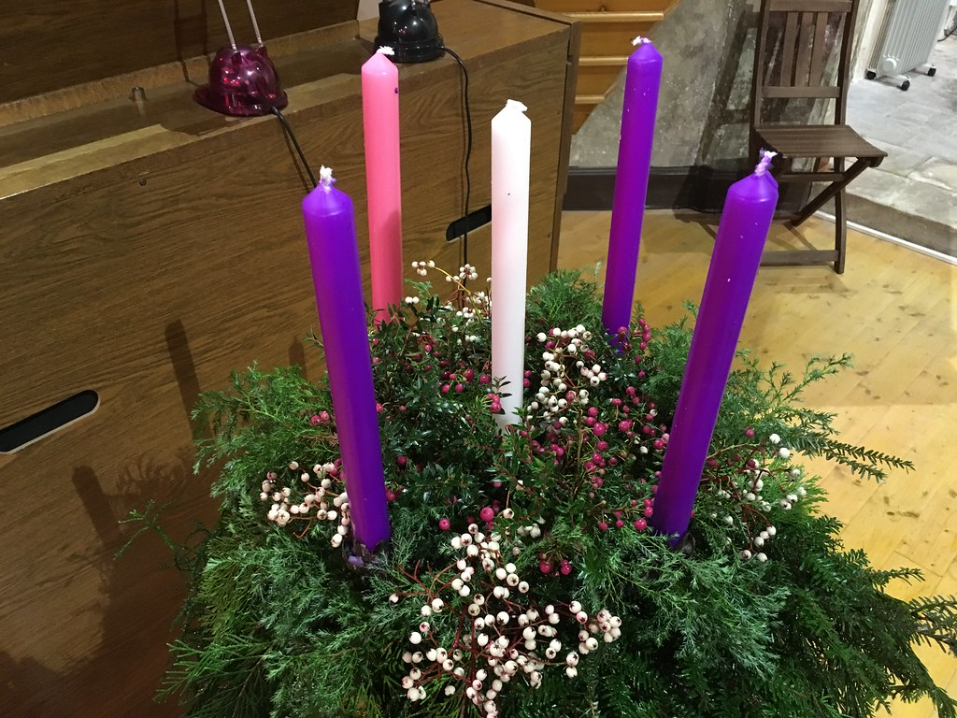

St. Mary’s 10.00 am Family Service
St James 9.30 am Holy Communion
St Barnabas 10.45 am Holy Communion
3.00 pm Confirmation preparation
4.00 pm Sunday@4
St John’s 8.00 am Holy Communion
10.00 am Holy Communion
Wednesday 10.00 am Holy Communion
Friday Livestreamed Communion Service also available to view after.

Sunday 28th November
9.00 am Team Zoom
Service
Saturday 27th November
5.30 pm Nightwatch Zoom Service

The Collect Almighty God, give us grace to cast away the works of darkness and to put on the armour of light, now in the time of this mortal life, in which your Son Jesus Christ came to us in great humility; that on the last day, when he shall come again in his glorious majesty to judge the living and the dead, we may rise to the life immortal; through him who is alive and reigns with you, in the unity of the Holy Spirit, one God, now and for ever.
The Additional Collect: Almighty God, as your kingdom dawns, turn us from the darkness of sin to the light of holiness, that we may be ready to meet you in our Lord and Saviour, Jesus Christ

Bible readings Jeremiah 33 v14-16 1 Thessalonians 3 v9-13 Luke 21 v25-36

St Mary’s News The PCC has agreed the provision of a new church boiler and ancillary works. The work will be done as soon as our heating engineers can fit us in. Help needed- flower arranging, bell tolling before services and funerals, please see warden or vicar for further information.

Forthcoming events

Friends of St Mary’s Christmas Bazaar Saturday 4th December 11.00 am - 2.00 pm St Mary’s Hall, Manor Road. Cakes and preserves, gifts, raffle, tombola, toys, knitted blankets and scarves, refreshments and hot lunches. There is a box at the back of the church (near the choir vestry door) for donations to the Bazaar or they may be delivered to the Hall on the Friday evening between 4 and 6 pm.
Deanery Confirmation Service Tuesday 7th December at 7.00 pm, St John’s, Sidcup. Please pray for those being received into the Church of England, baptised, confirmed and renewing baptismal vows at this service and particularly Patrick (St John’s) being received into the Church of England and Heather (St John’s) and Alexis (St Mary’s) who are to be baptised and confirmed.
Christian Stewardship

For St Barnabas Any contributions can be dropped off at the Treasurer’s house or at the Vicarage. Or you can give by BACS transfer. In all cases, if you are a taxpayer, please ‘Gift Aid’ your giving. If you have any questions regarding this, please contact David Peters on 01322 529796 or email davidpeters45@hotmail.co.uk

For St James, North Cray Contributions can be dropped off at 91 The Grove, or made by BACS transfer, contact Suzy Higgs on 07799072548. Please make cheques payable to St James, North Cray PCC.

For St John’s You can give to the continuing upkeep and ministry of St John’s via our Just Giving page:www.justgving.com/stjohntheevangelist-bexley

For St Mary’s If you ordinarily make your financial contributions in church, but in the present circumstances wish to contribute by cheque then please make your cheque payable to St Mary’s Bexley PCC and send it,
c/o C Lee 11 Holmesdale Road Bexleyheath DA7 4TJ your continued support is much appreciated.

St John’s Sermons are posted each Sunday at fatheredwardbarlow.wordpress.com
Social media – engage with us via Facebook (/stjohnsbexley, Twitter (@stjohnsbexley) and Instagram (@stjohnsbexley)

Rev’d Matt is now putting his sermons on a blog which can be found here https://revmatthodder.blogspot.com/

Zoom Services - we are introducing some new songs! If you would like to hear them visit the St James website and follow the link https://www.stjamesnorthcray.org.uk/

THE BEXLEY TEAM CLERGY
Team Rector: Rev’d Canon Ren Harding renharding@hotmail.co.uk 01322 528923 07836644782
Associate Priest: Rev’d Sue Twynam setwynam@gmail.com 01322559501 07952468127
Team Vicar: Rev’d Edward Barlow fr.edwardbarlow@gmail.com 01322 521786
Team Vicar: Rev’d Clive Wood revclivewood@gmail.com 01322 270942 07982392809
Team Curate: Rev’d Matt Hodder matthodder10@gmail.com 07889873125

