Bexley Team News

St Barnabas, Joydens Wood
St James, North Cray
St John the Evangelist, Bexley
St Mary the Virgin, Bexley

17th October 2021 Issue 83 Twentieth Sunday after Trinity
This is our God, the Servant King, he calls us now to follow him, to bring our lives as a daily offering, of worship to the servant King.

Graham Kendrick
St Mary’s 8.30 am BCP Holy Communion
10.00 am Holy Communion
St James 9.30am Holy Communion
3.00 pm Forest Church
St Barnabas 10.45am Holy Communion
St John’s 8.00 am Holy Communion
10.00 am Holy Communion
Friday Livestreamed Service of Holy Communion:
www.facebook.com/stjohnsbexleyTimes may vary
(see St John’s social media in advance) but the
service remains available to view after broadcast
Sunday 17th October
9.00 am Zoom Service
Saturday 16th October
5.30 pm Nightwatch Zoom Service

Children’s Church Harvest Special
Tune in this month to see how we are celebrating harvest this year. Join us for stories, prayers and a very tricky harvest quiz!
https://m.youtube.com/channel/UCPTwEiJwqMXAA98yC2oTiGw

The Collect for 20th after Trinity God, the giver of life, whose Holy Spirit wells up within your Church; by the Spirits gifts equip us to live the gospel of Christ and make us eager to do your will, that we may share with the whole creation the joys of eternal life; through Jesus Christ your Son our Lord, who is alive and reigns with you, in the unity of the Holy Spirit, one God, now and for ever.

Bible readings for 20th after Trinity Isaiah 53 v4 -12 Hebrews 5 v1-10 Mark 10 v35-45
The Additional Collect God, our light and our salvation, illuminate our lives, that we may see your goodness in the land of the living, and looking on your beauty may be changed into the likeness of Jesus Christ our Lord.
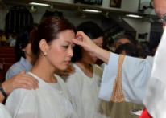
Considering Confirmation? A meeting for all those interested in being confirmed is being held on Sunday 7th November at 4.00 pm at St Barnabas Church, Joydens Wood. For further information or to indicate attendance please speak with any of the Team clergy.

News about harvest collections St James collected 86kg of items for the food bank at their Harvest Worship. The local Uniformed Organisations came along including representatives of their new Squirrel Scouts section.
St Barnabas collection of tins and packages was given to the Home-Start charity working with local vulnerable families. Our local Scout groups attended.
St Mary’s Harvest gifts have now been taken to Bexley Food Bank. The harvest gift of £136 towards the work of Bexley Women’s Aid has been sent to them.
St Johns - Gifts of non perishable foods, toiletries and sanitary products for the Bexley Foodbank were gratefully received at the 10am services in the 3rd and 10th October. At the Harvest Supper following Evensong on the 10th we were privileged to be joined by our guests of honour, Gill Bates, who spoke about the work of the Foodbank and Gill Rogers, our Foodbank Liaison. The total of the financial collection taken for the work of the Foodbank is still to be confirmed. Many thanks to all who gave so generously.
Zoom Services - we are introducing some new songs! If you would like to hear them visit the St James website and follow the link. https://www.stjamesnorthcray.org.uk/

Forthcoming events
The Walking Group Our next walk will be a gentle potter around the Foots Cray Meadows and will begin at St James North Cray on Saturday 16th October at 11.00 am. This walk is graded at 'Disciple Level' (suitable for little legs or frail knees). Please bring a packed lunch. For more information, please contact Rev'd Edward, you are welcome to simply turn up on the day.

Bexley Interfaith Forum The first in-person meeting of the Bexley Interfaith Forum in over 20 months will be held on Wednesday 20th October at 7.30pm at Christ Church, Bexleyheath. The session will be on the theme of Mental Health and will include Mental Health Chaplain, the Rev’d Neil Bunker and other specialists from local mental health groups and charities. There will also be a chance to meet members of different faith groups from across the borough over refreshments.

Friends of St Mary’s and the Grove Singers present ‘A Celebration of Birds in Song’
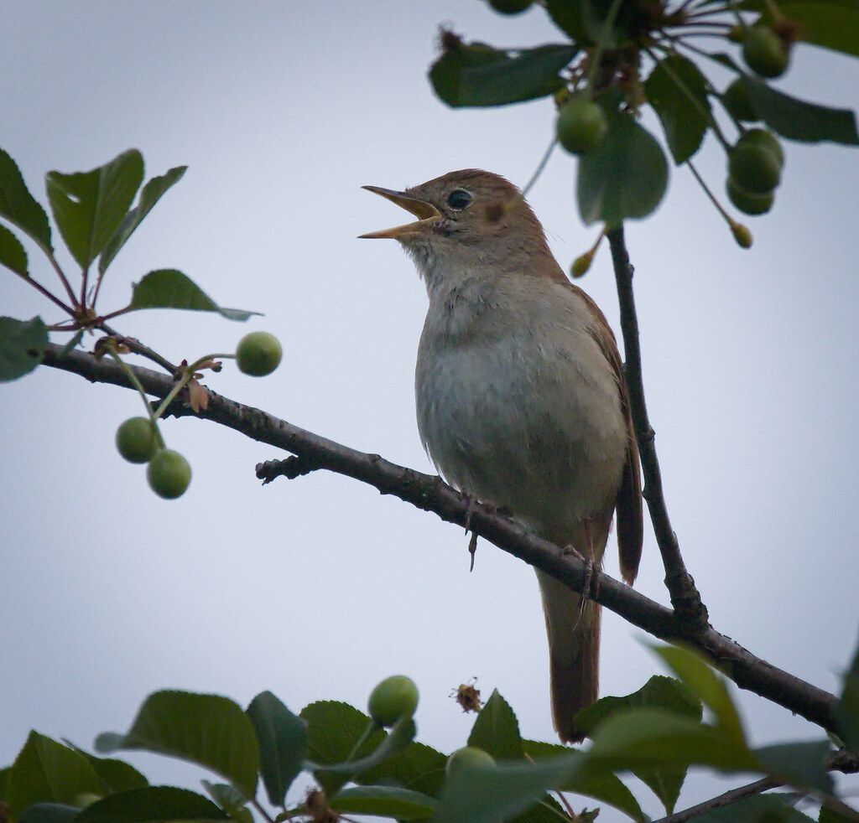
Saturday 30th October at 7.00 pm. Tickets £10 including refreshments from Roger
and Sheila Thompson 01322 522071 or Barbara Graham 0208 308 0872 or at the
door. Proceeds to Friends of St Mary’s.

North Cray community Festival of Remembrance Sunday 7th November (the weekend before Remembrance Sunday) Programme - 9.30 am BCP Holy Communion at St James. Followed by a parade from the War Memorial to the Scouts’ Geoffrey Hall, Leafield Lane, North Cray where there will be a display of stories and memorabilia.

St John's 27th November: Douze Noels Harp Recital

Christian Stewardship
For St Barnabas Any contributions can be dropped off at the Treasurer’s house or at the Vicarage. Or you can give by BACS transfer. In all cases, if you are a taxpayer please “Gift Aid” your giving. If you have any questions regarding this please contact, David Peters on 01322 529796 or by email davidpeters45@hotmail.co.uk
For St James, North Cray Contributions can be dropped off at 91 The Grove, or made by BACS transfer, contact Suzy Higgs on 07799072548.Please make cheques payable to St James, North Cray PCC.
For St John's You can give to the continuing upkeep and ministry of St John's via our Just Giving page: www.justgiving.com/stjohntheevangelist-bexley
For St Mary’s If you ordinarily make your financial contributions in church but, in the present circumstances, wish to contribute by cheque then please make your cheque payable to St Mary’s Bexley PCC and send it c/o C. Lee 11 Holmesdale Road, Bexleyheath, DA7 4TJ. Your continued support is very much appreciated
Each week the musicians at St James North Cray offer links to a selection of songs and music for us to enjoy. These can be found on our website www.stjamesnorthcray.org.uk/welcome/music/
St John’s Sermons are posted each Sunday at fatheredwardbarlow.wordpress.comSocial Media - engage with us via Facebook (/stjohnsbexley), Twitter (@stjohnsbexley) and Instagram (@stjohnsbexley)

THE BEXLEY TEAM CLERGY
Team Rector: Rev’d Canon Ren Hardingrenharding@hotmail.co.uk 01322 528923 07836644782
Associate Priest: Rev’d Sue Twynam setwynam@gmail.com 01322 55950 07952 468127
Team Vicar: Rev’d Edward Barlow fr.edwardbarlow@gmail.com 01322 521786
Team Vicar: Rev’d Clive Wood revclivewood@gmail.com 01322 270942 07982 392809
Team Curate: Rev’d Matt Hodder matthodder10@gmail.com 07889873125

